INTERNET PROGRAMMING LAB
EasyToll - Online Toll Payment

Aim
To design and develop EasyToll, an online toll payment system with user eWallet, toll eTickets, toll passes with QR codes, toll gate verification and administrator control of toll plazas and pass approval.

Technologies Used
- HTML5 - page structure and forms
- CSS3 - responsive layout and styling
- JavaScript (ES6) - client-side logic, validation and role-based access
- Browser localStorage - data storage (no server needed)

Modules and Functionalities
Admin
- Create Toll Details
- Approve Toll Pass
- Manage Users
- Manage Toll Login
- All eTickets
- Report
- My Profile
User
- Add Money - eWallet
- Buy Toll eTicket
- Apply / Renew Toll Pass
- My Passes & QR
- My eTickets
- Wallet History
- My Profile
Toll Gate User
- Scan QR / Verify Pass or Ticket
- Update Toll Location
- My Profile

Business Rules Implemented
- Toll tickets and passes are paid from the eWallet balance; insufficient balance is rejected.
- A QR code is generated when the administrator approves a pass.
- Toll gate users verify a pass or ticket code.

Algorithm / Procedure
- Open the HTML file in a web browser; the login page is displayed.
- Log in with an existing account, or register a new user (Register button).
- On login, the menu for that role is built from the role-page configuration.
- Each page reads and writes records through the common save() routine, which runs the validation rules and updates stock/amount.
- Tables are rendered from the stored records; search and filter options refine the list.
- Logout clears the session and returns to the login page.

Demo Login Details
Role | Username | Password
Admin | admin | admin123
User | user | user123
Toll Gate User | tollgateuser | tollgateuser123

Source Code
File: 15_easytoll_payment.html
<!DOCTYPE html>
<html lang="en">
<head>
<meta charset="utf-8" />
<meta name="viewport" content="width=device-width,initial-scale=1" />
<title>EasyToll - Online Toll Payment</title>
<style>
:root {
--c: #d35400;
}
* {
box-sizing: border-box;
}
body {
margin: 0;
font-family: system-ui, Arial, sans-serif;
background: #f4f6fa;
color: #222;
}
header {
background: var(--c);
color: #fff;
padding: 12px 20px;
display: flex;
flex-wrap: wrap;
gap: 10px;
align-items: center;
justify-content: space-between;
}
header h1 {
font-size: 1.2rem;
margin: 0;
}
nav {
display: flex;
flex-wrap: wrap;
gap: 6px;
align-items: center;
}
nav button {
background: #fff;
color: var(--c);
border: 0;
border-radius: 6px;
padding: 7px 12px;
cursor: pointer;
font-size: 0.88rem;
}
.b {
background: var(--c);
color: #fff;
border: 0;
border-radius: 6px;
padding: 7px 12px;
cursor: pointer;
margin: 2px;
font-size: 0.88rem;
}
.b.r {
background: #c0392b;
}
main {
max-width: 1150px;
margin: 20px auto;
padding: 0 14px;
}
.card {
background: #fff;
border-radius: 10px;
padding: 16px;
margin: 12px 0;
box-shadow: 0 1px 4px #0002;
}
label {
display: block;
font-size: 0.85rem;
margin: 8px 0 3px;
}
input,
select {
width: 100%;
padding: 8px;
border: 1px solid #bbb;
border-radius: 6px;
font: inherit;
}
.g {
display: grid;
grid-template-columns: repeat(auto-fit, minmax(210px, 1fr));
gap: 0 14px;
}
table {
width: 100%;
border-collapse: collapse;
background: #fff;
}
th,
td {
padding: 8px;
border-bottom: 1px solid #e3e3e3;
text-align: left;
font-size: 0.86rem;
}
th {
background: #eef1f6;
}
.tw {
overflow-x: auto;
}
.s {
display: flex;
gap: 8px;
flex-wrap: wrap;
align-items: center;
}
.s input,
.s select {
width: auto;
flex: 1;
min-width: 140px;
}
.stat {
display: inline-block;
background: #fff;
border-left: 5px solid var(--c);
padding: 12px 20px;
margin: 6px;
border-radius: 8px;
box-shadow: 0 1px 4px #0002;
}
.stat b {
font-size: 1.5rem;
display: block;
}
a {
color: var(--c);
}
small {
color: #666;
}
</style>
<script src="https://cdnjs.cloudflare.com/ajax/libs/qrcodejs/1.0.0/qrcode.min.js"></script>
</head>
<body>
<header>
<h1>🛣️ EasyToll - Online Toll Payment</h1>
<nav id="nav"></nav>
</header>
<main id="main"></main>
<footer style="text-align: center; padding: 20px">
<small
>Demo app - data is stored in your browser (localStorage) -
<a
href="#"
onclick="
resetDemo();
return false;
"
>reset demo data</a
></small
>
</footer>
<script>
const A = {
id: "exp15",
t: "EasyToll - Online Toll Payment",
roles: { Admin: { reg: 0 }, User: { reg: 1 }, "Toll Gate User": { reg: 0 } },
ent: {
Plazas: "name,location,fee:number",
Wallet: "amount:number,mode:select:UPI|Card|NetBanking,kind~:select:Credit|Debit,note~",
Tickets: "plaza:ref:Plazas.name,vehicle,code~,amount~:number,status~:select:Valid|Used",
Passes:
"vehicle,plaza:ref:Plazas.name,type:select:Monthly|Yearly,amount~:number,status~:select:Pending|Approved|Rejected,qr~",
},
seed: {
Plazas:
"Chennai Bypass Plaza|NH48 Chennai|85;Walajapet Plaza|NH48 Ranipet|110;Krishnagiri Plaza|NH44 Krishnagiri|135",
},
pages: {
Admin: [
["Create Toll Details", "crud", "Plazas"],
["Approve Toll Pass", "crud", "Passes"],
["Manage Users", "users", "User"],
["Manage Toll Login", "newuser", "Toll Gate User"],
["All eTickets", "crud", "Tickets"],
["Report", "report", "", { sum: [["Passes (Rs)", "Passes", "amount"]] }],
],
User: [
["Add Money - eWallet", "add", "Wallet", {}],
["Buy Toll eTicket", "add", "Tickets", {}],
["Apply / Renew Toll Pass", "add", "Passes", {}],
["My Passes & QR", "mine", "Passes", { qr: ["Show QR", "qr"] }],
["My eTickets", "mine", "Tickets", { qr: ["Show QR", "code"] }],
["Wallet History", "mine", "Wallet"],
],
"Toll Gate User": [
[
"Scan QR / Verify Pass or Ticket",
"verify",
"",
{
list: [
["Passes", "qr"],
["Tickets", "code"],
],
},
],
["Update Toll Location", "crud", "Plazas"],
],
},
inv: {},
own: {},
};
const P = A.id + "_",
$ = (i) => document.getElementById(i);
const mem = {},
LS = (() => {
try {
localStorage.setItem("_t", 1);
localStorage.removeItem("_t");
const l = localStorage;
return {
getItem: (k) => l.getItem(k),
setItem: (k, v) => l.setItem(k, v),
removeItem: (k) => l.removeItem(k),
keys: () => Object.keys(l),
};
} catch (e) {
return {
getItem: (k) => mem[k] ?? null,
setItem: (k, v) => {
mem[k] = String(v);
},
removeItem: (k) => {
delete mem[k];
},
keys: () => Object.keys(mem),
};
}
})();
const SS = {
get: (k) => {
try {
return sessionStorage.getItem(k) || mem["s" + k];
} catch (e) {
return mem["s" + k];
}
},
set: (k, v) => {
mem["s" + k] = v;
try {
sessionStorage.setItem(k, v);
} catch (e) {}
},
del: (k) => {
delete mem["s" + k];
try {
sessionStorage.removeItem(k);
} catch (e) {}
},
};
const L = (s) => JSON.parse(LS.getItem(P + s) || "[]"),
W = (s, v) => LS.setItem(P + s, JSON.stringify(v));
const today = () => new Date().toISOString().slice(0, 10),
add = (d, n) => {
const x = new Date(d);
x.setDate(x.getDate() + n);
return x.toISOString().slice(0, 10);
},
diff = (a, b) => Math.round((new Date(b) - new Date(a)) / 864e5);
const uid = () => Date.now().toString(36) + Math.random().toString(36).slice(2, 6);
const lab = (k) => k.replace(/([A-Z])/g, " $1").replace(/^./, (c) => c.toUpperCase());
const E = (s) =>
String(s ?? "").replace(
/[&<>"]/g,
(c) => ({ "&": "&amp;", "<": "&lt;", ">": "&gt;", '"': "&quot;" })[c],
);
const FS = (s) =>
s.split(",").map((x) => {
let [k, t = "text", ...o] = x.split(":");
const auto = k.endsWith("~"),
opt = auto || k.endsWith("?");
k = k.replace(/[~?]$/, "");
return { k, t, auto, opt, o: o.join(":").split("|") };
});
let act = [];
const R = (f) => act.push(f) - 1;
const me = () => L("Users").find((u) => u.id == SS.get(P + "me"));
const roles = Object.keys(A.roles),
adm = roles[0],
slug = (r) => r.toLowerCase().replace(/\W/g, "");
const M = (h) => {
$("main").innerHTML = h;
};
const HK = {},
CALC = {};
let BD = () => "";
const bal = () =>
L("Wallet")
.filter((w) => w.owner == me().id)
.reduce((s, w) => s + (w.kind == "Credit" ? w.amount : -w.amount), 0);
const debit = (a, n) => {
const w = L("Wallet");
w.push({
id: uid(),
owner: me().id,
amount: a,
mode: "Wallet",
kind: "Debit",
note: n,
created: today(),
});
W("Wallet", w);
};
Object.assign(HK, {
Tickets: (v, old) => {
if (!old) {
const p = L("Plazas").find((x) => x.name == v.plaza);
if (bal() < p.fee) return "Insufficient wallet balance - add money first";
v.amount = p.fee;
v.code = "TKT" + Math.floor(1e5 + Math.random() * 9e5);
debit(p.fee, "Toll ticket " + v.code);
}
},
Passes: (v, old) => {
if (!old) {
const p = L("Plazas").find((x) => x.name == v.plaza),
a = p.fee * (v.type == "Yearly" ? 300 : 25);
if (bal() < a) return "Insufficient wallet balance (pass costs Rs " + a + ")";
v.amount = a;
debit(a, "Toll pass");
} else if (v.status == "Approved" && !old.qr) v.qr = "QR" + old.id.toUpperCase();
},
});
Object.assign(CALC, {});
BD = () => (me().role == "User" ? " | Wallet: Rs " + bal() : "");
const inp = (f, v, ro) => {
const id = "f_" + f.k,
d = ro ? "disabled" : "";
if (f.t == "select" || f.t == "ref") {
let os = f.o;
if (f.t == "ref") {
const [e, k] = f.o[0].split(".");
os = [...new Set(L(e).map((r) => r[k]))];
}
return `<select id=${id} ${d}>${os.map((o) => `<option ${o == v ? "selected" : ""}>${E(o)}</option>`).join("")}</select>`;
}
return `<input id=${id} type=${["number", "date", "password"].includes(f.t) ? f.t : "text"} value="${E(v)}" ${d}>`;
};
const form = (fs, v = {}, ro = [], hide) =>
`<div class=g>${fs
.filter((f) => !(hide && f.auto))
.map(
(f) =>
`<div><label>${lab(f.k)}${f.opt ? "" : " *"}</label>${inp(f, v[f.k] ?? "", ro.includes(f.k))}</div>`,
)
.join("")}</div>`;
function read(fs, hide, old) {
const o = {};
for (const f of fs) {
if (hide && f.auto) {
if (!old) o[f.k] = f.t == "select" ? f.o[0] : f.t == "number" ? 0 : "";
continue;
}
const v = $("f_" + f.k).value.trim();
if (v === "" && !f.opt) {
alert("Please fill: " + lab(f.k));
return null;
}
o[f.k] = f.t == "number" && v !== "" ? +v : v;
}
return o;
}
function cell(f, v) {
if (f.t == "map")
return v
? `<a target=_blank href="https://www.google.com/maps/search/?api=1&query=${encodeURIComponent(v)}">&#128205; Map</a>`
: "";
return /^https?:/.test(v) ? `<a target=_blank href="${E(v)}">Open / Download</a>` : E(v);
}
function T(fs, rows, acts = [], xc) {
const ex = xc ? rows.map(xc) : [],
xk = ex[0] ? Object.keys(ex[0]) : [];
return `<div class=tw><table><tr>${fs.map((f) => `<th>${lab(f.k)}</th>`).join("")}${xk.map((k) => `<th>${lab(k)}</th>`).join("")}<th></th></tr>${rows.map((r, i) => `<tr>${fs.map((f) => `<td>${cell(f, r[f.k])}</td>`).join("")}${xk.map((k) => `<td>${E(ex[i][k])}</td>`).join("")}<td>${acts.map((a) => `<button class="b ${a[2] || ""}" onclick="act[${R(() => a[1](r))}]()">${a[0]}</button>`).join("")}</td></tr>`).join("") || "<tr><td colspan=30>No records found</td></tr>"}</table></div>`;
}
function inv(iv, v, old) {
const items = L(iv.to),
it = items.find((x) => x[iv.key] == (v[iv.f] ?? (old && old[iv.f])));
if (!it) return "Item not found";
const q = iv.qty ? +(v[iv.qty] ?? (old && old[iv.qty]) ?? 1) : 1,
[rk, rv] = iv.rel;
if (!old) {
if (it[iv.stock] < q) {
if (iv.wl) v.status = "Waiting";
else return "Sorry, not available / out of stock";
} else it[iv.stock] -= q;
if (iv.price) v.amount = it[iv.price] * q;
} else if (old[rk] != rv && v[rk] == rv && old.status != "Waiting") it[iv.stock] += q;
W(iv.to, items);
}
function save(en, v, old) {
const m = me();
v.owner = old ? old.owner : m.id;
if (!old) {
v.by = m.id;
const o = A.own && A.own[en];
if (o) {
const u = L("Users").find((u) => u.username == v[o]);
if (u) v.owner = u.id;
}
}
const h = HK[en];
if (h) {
const e = h(v, old);
if (e) {
alert(e);
return;
}
}
const iv = A.inv && A.inv[en];
if (iv) {
const e = inv(iv, v, old);
if (e) {
alert(e);
return;
}
}
const rows = L(en);
if (old) {
const i = rows.findIndex((r) => r.id == old.id);
rows[i] = { ...old, ...v };
} else {
v.id = uid();
v.created = today();
rows.push(v);
}
W(en, rows);
return 1;
}
function crud(l, en, o, ed) {
act = [];
const fs = FS(A.ent[en]);
M(
`<h2>${l}</h2><div class=card><h3>${ed ? "Edit record" : "Add new"}</h3>${form(fs, ed || {})}<br><button class=b onclick="act[${R(
() => {
const v = read(fs);
if (v && save(en, v, ed)) crud(l, en, o);
},
)}]()">Save</button>${ed ? `<button class=b onclick="act[${R(() => crud(l, en, o))}]()">Cancel</button>` : ""}</div>${T(
fs,
L(en),
[
["Edit", (r) => crud(l, en, o, r)],
[
"Delete",
(r) => {
if (confirm("Delete this record?")) {
W(
en,
L(en).filter((x) => x.id != r.id),
);
crud(l, en, o);
}
},
"r",
],
],
CALC[en],
)}`,
);
}
function doAct(a, item, back, src) {
const [lb, to, map, direct] = a,
fs = FS(A.ent[to]),
pre = {};
for (const k in map) {
const s = map[k];
pre[k] = s[0] == "=" ? s.slice(1) : item[s];
}
const fin = (v) => {
if (v && save(to, v)) {
if (src)
W(
src[0],
L(src[0]).filter((x) => x.id != src[1]),
);
alert("Done: " + lb);
back();
}
};
if (direct) {
const v = {};
fs.forEach(
(f) =>
(v[f.k] =
f.k in pre
? f.t == "number"
? +pre[f.k]
: pre[f.k]
: f.t == "select"
? f.o[0]
: f.t == "number"
? 0
: ""),
);
return fin(v);
}
act = [];
M(
`<h2>${lb}</h2><div class=card>${form(fs, pre, Object.keys(pre), 1)}<br><button class=b onclick="act[${R(() => fin(read(fs, 1)))}]()">Confirm</button><button class=b onclick="act[${R(back)}]()">Back</button></div>`,
);
}
function browse(l, en, o, q0 = "") {
act = [];
const fs = FS(A.ent[en]),
find = (o.find || fs[0].k).split(","),
fl = o.flt,
back = () => browse(l, en, o);
const draw = () => {
const q = $("q").value.toLowerCase(),
f = fl ? $("fl").value : "",
mx = o.rng && $("mx").value;
const rs = L(en).filter(
(r) =>
find.some((k) => String(r[k]).toLowerCase().includes(q)) &&
(!f || r[fl] == f) &&
(!mx || r[o.rng] <= +mx),
);
$("res").innerHTML = T(
fs,
rs,
(o.acts || []).map((a) => [a[0], (r) => doAct(a, r, back)]),
CALC[en],
);
};
const di = R(draw);
M(
`<h2>${l}</h2><div class="card s"><input id=q oninput="act[${di}]()" placeholder="Search by ${find.map(lab).join(", ")}" value="${E(q0)}">${fl ? `<select id=fl onchange="act[${di}]()"><option value="">All ${lab(fl)}</option>${[...new Set(L(en).map((r) => r[fl]))].map((v) => `<option>${E(v)}</option>`).join("")}</select>` : ""}${o.rng ? `<input id=mx type=number oninput="act[${di}]()" placeholder="Max ${lab(o.rng)}">` : ""}<button class=b onclick="act[${di}]()">Search</button></div><div id=res></div>`,
);
draw();
}
function mine(l, en, o) {
act = [];
const fs = FS(A.ent[en]),
m = me(),
back = () => mine(l, en, o);
let rows = L(en).filter((r) => r.owner == m.id);
if (o.cf) rows = rows.filter((r) => CALC[en](r)[o.cf] > 0);
const ac = [];
(o.sets || []).forEach((s) =>
ac.push([
s[0],
(r) => {
if (r[s[2]] == s[3]) return alert("Not applicable");
if (save(en, { ...s[1] }, r)) back();
},
"r",
]),
);
if (o.edit)
ac.push([
"Modify",
(r) => {
act = [];
M(
`<h2>Modify</h2><div class=card>${form(fs, r, [], 1)}<br><button class=b onclick="act[${R(
() => {
const v = read(fs, 1, r);
if (v && save(en, v, r)) back();
},
)}]()">Save</button><button class=b onclick="act[${R(back)}]()">Back</button></div>`,
);
},
]);
if (o.mv) ac.push([o.mv[0], (r) => doAct(o.mv, r, back, [en, r.id])]);
if (o.run)
ac.push([
o.run[0],
(r) => {
const p = A.pages[m.role].find((x) => x[0] == o.run[1]);
browse(p[0], p[2], p[3] || {}, r[o.run[2]]);
},
]);
if (o.print)
ac.push([
"Print",
(r) => {
const w = window.open("", "_blank");
w.document.write(
"<h2>" +
E(A.t) +
" - Ticket</h2>" +
Object.entries(r)
.filter(([k]) => !["id", "owner", "by"].includes(k))
.map(([k, v]) => "<p><b>" + lab(k) + ":</b> " + E(v) + "</p>")
.join(""),
);
w.document.close();
w.print();
},
]);
if (o.qr)
ac.push([
o.qr[0],
(r) => {
const c = r[o.qr[1]];
if (!c) return alert("Not available yet - waiting for approval");
const d = $("qr");
d.style.display = "block";
d.innerHTML = "<h3>" + E(c) + "</h3><div id=qc></div>";
window.QRCode && new QRCode($("qc"), c);
},
]);
if (o.del)
ac.push([
"Remove",
(r) => {
W(
en,
L(en).filter((x) => x.id != r.id),
);
back();
},
"r",
]);
M(`<h2>${l}</h2>${T(fs, rows, ac, CALC[en])}<div id=qr class=card style="display:none"></div>`);
}
function addp(l, en, o) {
act = [];
const fs = FS(A.ent[en]),
m = me(),
v0 = {};
for (const k in o.def || {}) v0[k] = o.def[k] == "@today" ? today() : o.def[k];
M(
`<h2>${l}</h2><div class=card>${form(fs, v0, [], 1)}<br><button class=b onclick="act[${R(() => {
const v = read(fs, 1);
if (v && save(en, v)) {
alert("Saved successfully");
addp(l, en, o);
}
})}]()">Submit</button></div><h3>Records</h3>${T(
fs,
L(en).filter((r) => m.role == adm || r.by == m.id),
[],
CALC[en],
)}`,
);
}
function profile() {
act = [];
const fs = FS("name,email,phone,password:password"),
m = me();
M(
`<h2>My Profile</h2><div class=card><p>Role: <b>${E(m.role)}</b> &nbsp; Username: <b>${E(m.username)}</b></p>${form(fs, m)}<br><button class=b onclick="act[${R(
() => {
const v = read(fs);
if (!v) return;
const u = L("Users");
Object.assign(
u.find((x) => x.id == m.id),
v,
);
W("Users", u);
alert("Profile updated");
profile();
},
)}]()">Update</button></div>`,
);
}
function report(l, _, o) {
act = [];
M(
`<h2>${l}</h2>${(o.sum || [])
.map(
(s) =>
`<div class=stat><b>${L(s[1])
.filter((r) => s[3] || r.status != "Cancelled")
.reduce((a, r) => a + (+r[s[2]] || 0), 0)}</b>${s[0]}</div>`,
)
.join("")}<br>${Object.keys(A.ent)
.map((e) => `<div class=stat><b>${L(e).length}</b>${lab(e)}</div>`)
.join(
"",
)}<br>${roles.map((r) => `<div class=stat><b>${L("Users").filter((u) => u.role == r).length}</b>${E(r)} accounts</div>`).join("")}`,
);
}
function users(l, role) {
act = [];
M(
`<h2>${l}</h2>${T(
FS("name,username,email,phone"),
L("Users").filter((u) => u.role == role),
[
[
"Delete",
(r) => {
if (confirm("Delete user?")) {
W(
"Users",
L("Users").filter((x) => x.id != r.id),
);
users(l, role);
}
},
"r",
],
],
)}`,
);
}
function approve(l, role) {
act = [];
M(
`<h2>${l}</h2>${T(
FS("name,username,email,phone,approved"),
L("Users").filter((u) => u.role == role),
[
[
"Approve",
(r) => {
const u = L("Users");
u.find((x) => x.id == r.id).approved = 1;
W("Users", u);
approve(l, role);
},
],
[
"Reject",
(r) => {
W(
"Users",
L("Users").filter((x) => x.id != r.id),
);
approve(l, role);
},
"r",
],
],
)}`,
);
}
function newuser(l, role) {
act = [];
const fs = FS("name,username,password:password,email,phone");
M(
`<h2>${l}</h2><div class=card>${form(fs)}<br><button class=b onclick="act[${R(() => {
const v = read(fs);
if (!v) return;
if (L("Users").some((u) => u.username == v.username)) return alert("Username already exists");
W("Users", [...L("Users"), { ...v, id: uid(), role, approved: 1 }]);
alert(role + " account created");
newuser(l, role);
})}]()">Create</button></div>${T(
FS("name,username,email,phone"),
L("Users").filter((u) => u.role == role),
)}`,
);
}
function find(l, en, o) {
act = [];
const fs = FS(A.ent[en]);
M(
`<h2>${l}</h2><div class="card s"><input id=k placeholder="Enter ${lab(o.key)}"><button class=b onclick="act[${R(
() => {
const k = $("k").value.trim();
$("res").innerHTML = T(
fs,
L(en).filter((r) => String(r[o.key]) == k),
[],
CALC[en],
);
},
)}]()">Check</button></div><div id=res></div>`,
);
}
function verify(l, _, o) {
act = [];
M(
`<h2>${l}</h2><div class="card s"><input id=k placeholder="Scan / enter QR code or ticket code"><button class=b onclick="act[${R(
() => {
const k = $("k").value.trim();
let h = "<div class=card>&#10060; <b>Invalid code</b></div>";
for (const [e, f] of o.list) {
const r = k && L(e).find((x) => x[f] == k);
if (r) h = "<div class=card>&#9989; <b>Valid " + lab(e) + "</b></div>" + T(FS(A.ent[e]), [r]);
}
$("res").innerHTML = h;
},
)}]()">Verify</button></div><div id=res></div>`,
);
}
const PG = { crud, browse, mine, add: addp, report, users, approve, newuser, find, verify };
function go(i) {
act = [];
const p = A.pages[me().role][i];
PG[p[1]](p[0], p[2], p[3] || {});
}
function home() {
const m = me();
if (!m) return login();
const ps = A.pages[m.role] || [];
$("nav").innerHTML =
ps.map((p, i) => `<button onclick="go(${i})">${p[0]}</button>`).join("") +
`<button onclick="profile()">My Profile</button><button onclick="logout()">Logout</button><span style="color:#fff;font-size:.8rem">${E(m.name)} (${E(m.role)}) ${BD()}</span>`;
ps.length ? go(0) : profile();
}
function logout() {
SS.del(P + "me");
$("nav").innerHTML = "";
login();
}
function login() {
act = [];
M(
`<div class=card style="max-width:460px;margin:30px auto"><h2>Login</h2><label>Username</label><input id=u><label>Password</label><input id=p type=password><br><br><button class=b onclick="doLogin()">Login</button><button class=b onclick="signup()">Register</button><button class=b onclick="forgot()">Forgot Password</button><hr><small>Demo accounts - click to log in instantly:</small><div>${roles.map((r) => `<button class=b onclick="doLogin('${slug(r)}','${slug(r)}123')">${r}</button>`).join("")}</div></div>`,
);
}
function doLogin(un, pw) {
un = un ?? $("u").value.trim();
pw = pw ?? $("p").value;
const u = L("Users").find((x) => x.username == un && x.password == pw);
if (!u) return alert("Invalid username or password");
if (!u.approved) return alert("Your account is awaiting admin approval");
SS.set(P + "me", u.id);
home();
}
function signup() {
act = [];
const fs = FS("name,username,password:password,email,phone"),
rr = roles.filter((r) => A.roles[r].reg);
M(
`<div class=card style="max-width:520px;margin:30px auto"><h2>Register</h2><label>Register as</label><select id=rr>${rr.map((r) => `<option>${r}</option>`).join("")}</select>${form(fs)}<br><button class=b onclick="act[${R(
() => {
const v = read(fs);
if (!v) return;
if (L("Users").some((u) => u.username == v.username)) return alert("Username already taken");
const role = $("rr").value,
ap = A.roles[role].appr;
W("Users", [...L("Users"), { ...v, id: uid(), role, approved: ap ? 0 : 1 }]);
alert(ap ? "Registered. Wait for admin approval." : "Registered. Please login.");
login();
},
)}]()">Register</button><button class=b onclick="login()">Back</button></div>`,
);
}
function forgot() {
const n = prompt("Enter your username");
if (!n) return;
const u = L("Users"),
x = u.find((y) => y.username == n);
if (!x) return alert("User not found");
const p = prompt("Enter new password");
if (!p) return;
x.password = p;
W("Users", u);
alert("Password reset. Please login.");
}
function resetDemo() {
LS.keys()
.filter((k) => k.startsWith(P))
.forEach((k) => LS.removeItem(k));
SS.del(P + "me");
location.reload();
}
if (!LS.getItem(P + "init")) {
W(
"Users",
roles.map((r) => {
const n = slug(r);
return {
id: uid(),
role: r,
username: n,
password: n + "123",
name: r + " Demo",
email: n + "@demo.com",
phone: "9999999999",
approved: 1,
};
}),
);
for (const e in A.seed) {
const fs = FS(A.ent[e]);
W(
e,
A.seed[e].split(";").map((r) => {
const o = { id: uid(), created: today() };
r.split("|").forEach((v, i) => (o[fs[i].k] = fs[i].t == "number" ? +v : v.trim()));
return o;
}),
);
}
LS.setItem(P + "init", 1);
}
me() ? home() : login();
</script>
</body>
</html>

Output
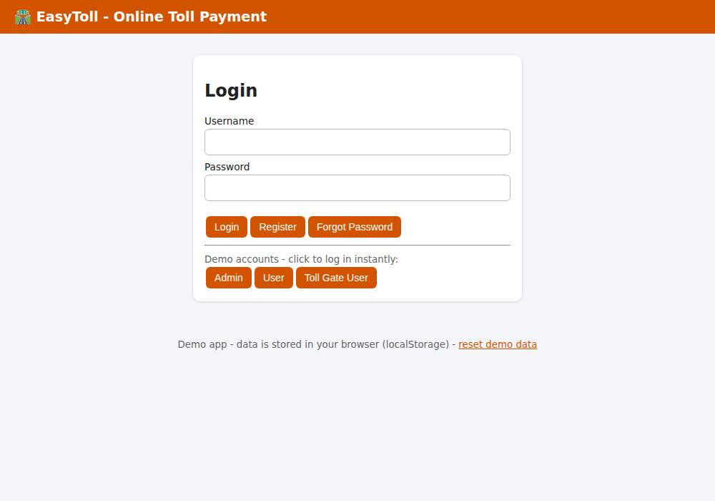
Figure 1: Login page with demo account buttons
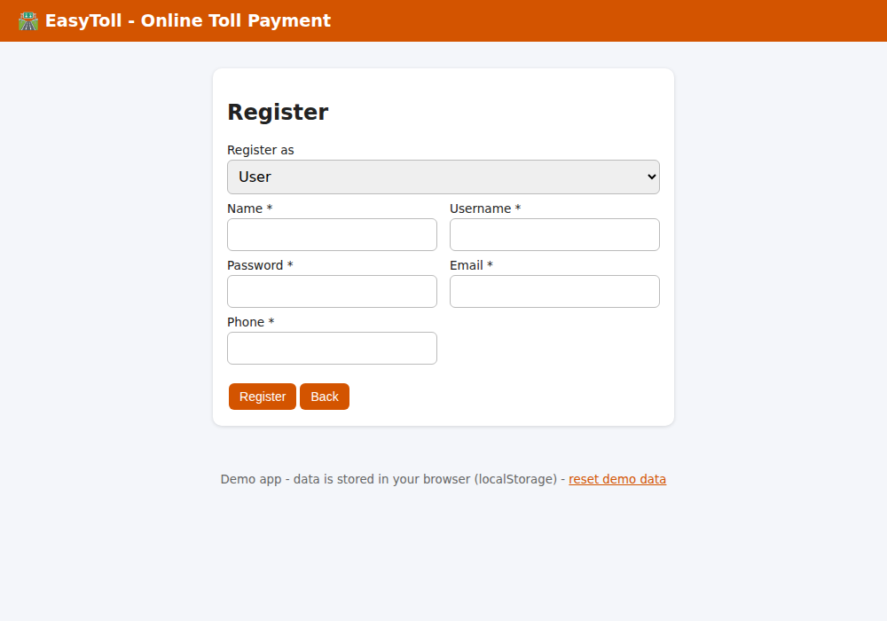
Figure 2: Registration page
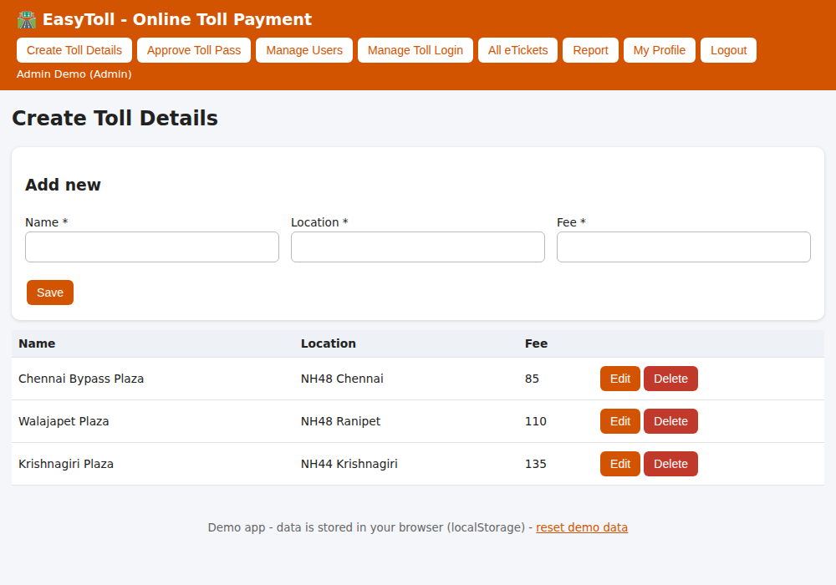
Figure 3: Admin - Create Toll Details
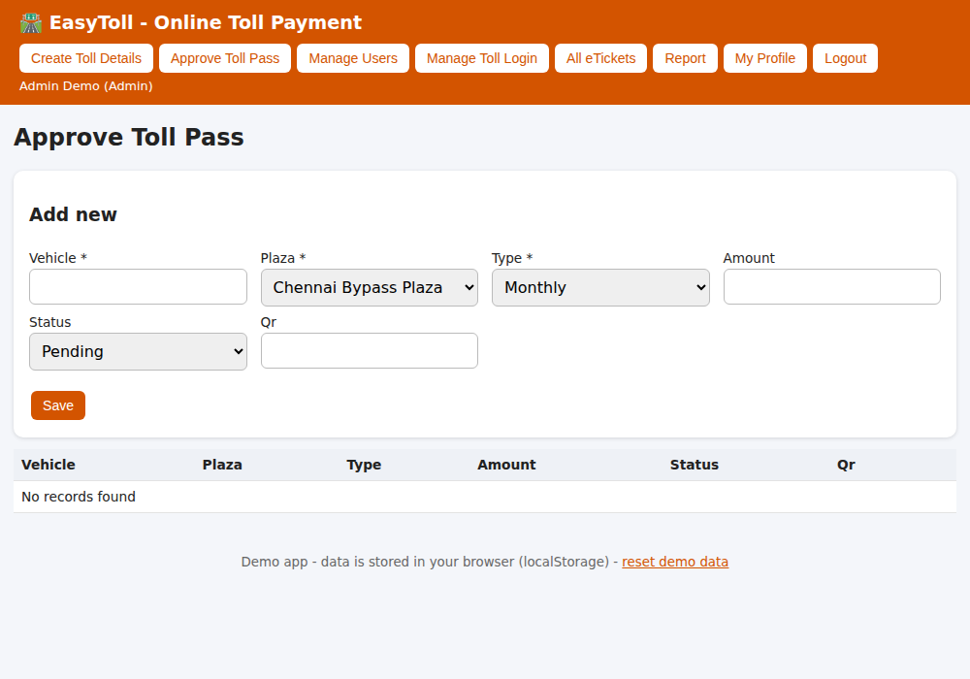
Figure 4: Admin - Approve Toll Pass
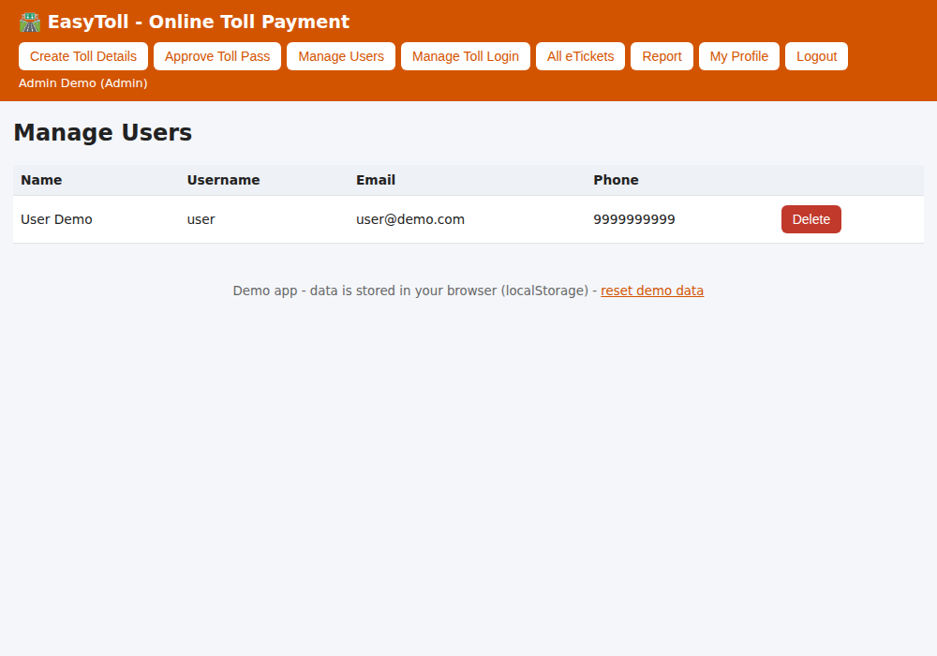
Figure 5: Admin - Manage Users
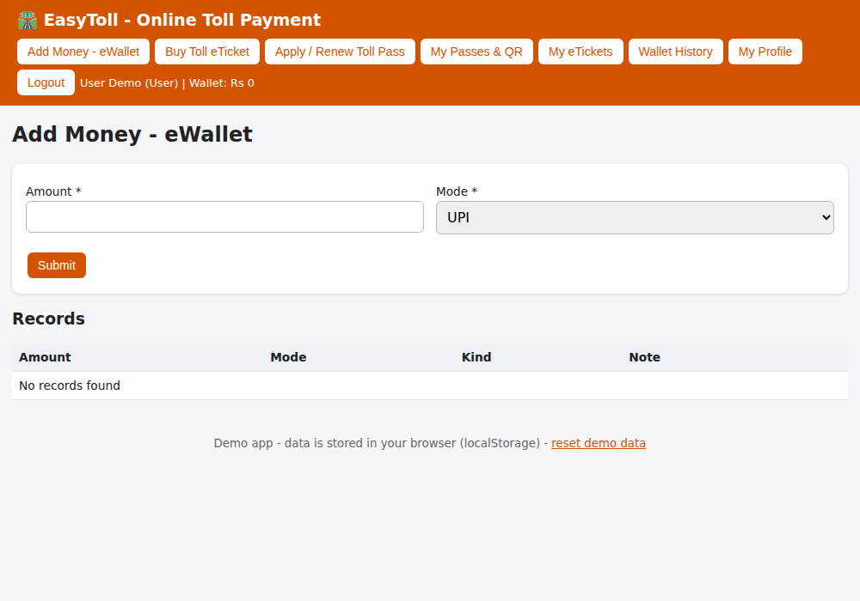
Figure 6: User - Add Money - eWallet
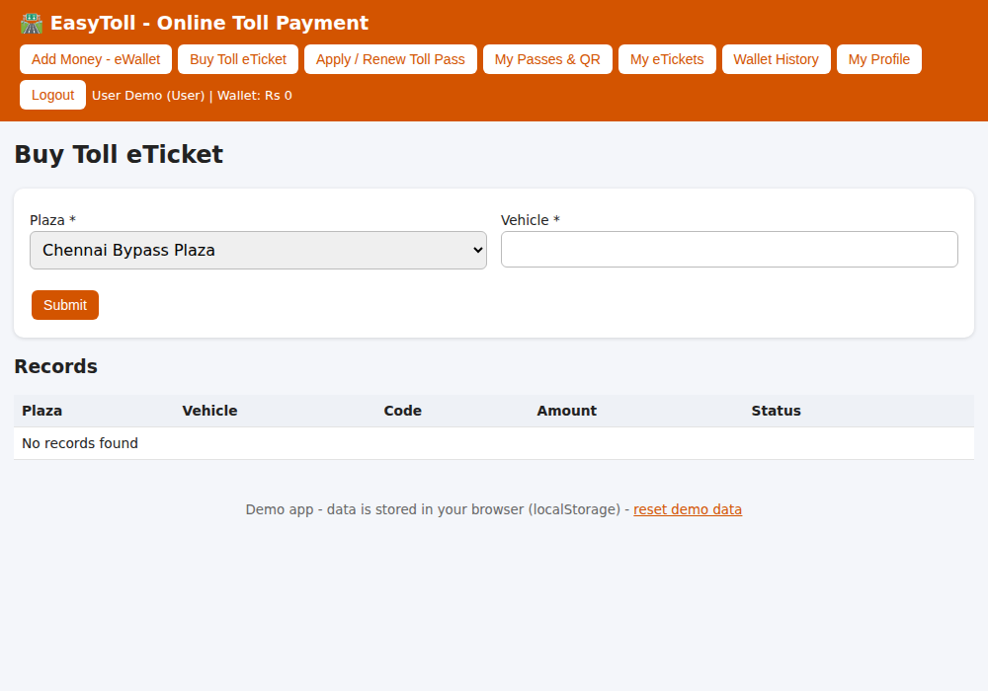
Figure 7: User - Buy Toll eTicket
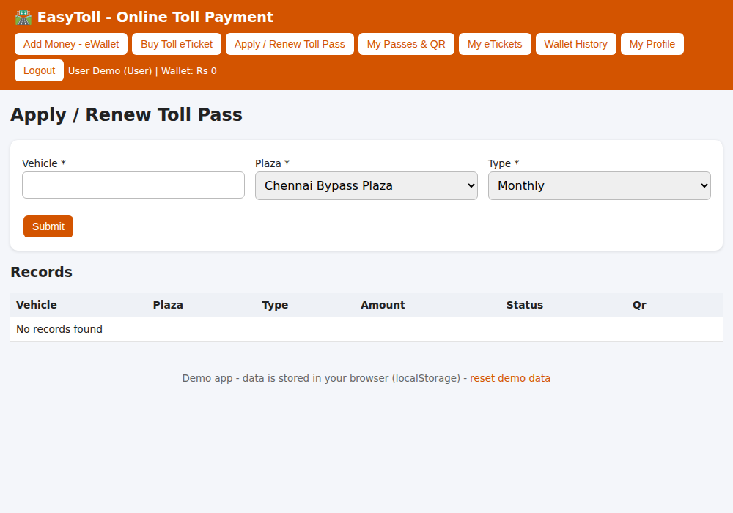
Figure 8: User - Apply / Renew Toll Pass
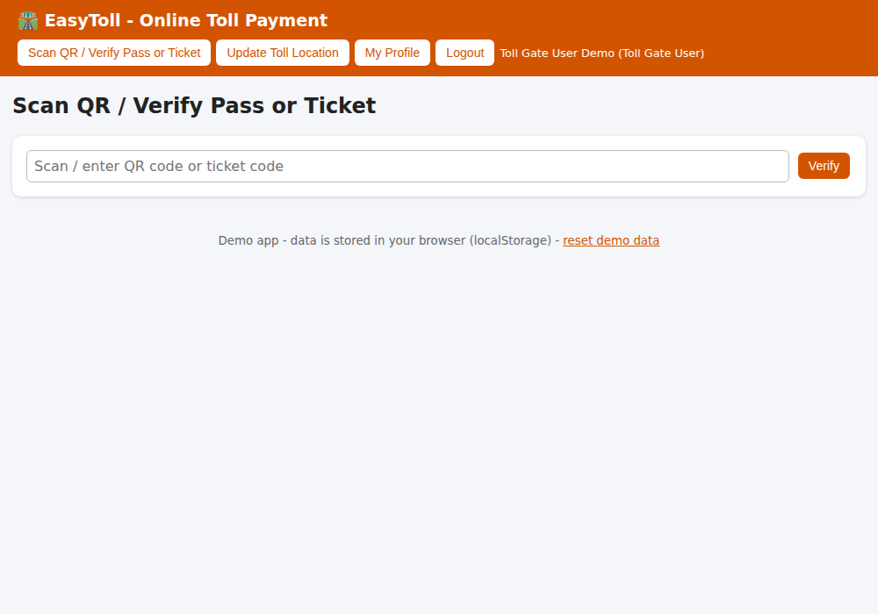
Figure 9: Toll Gate User - Scan QR / Verify Pass or Ticket
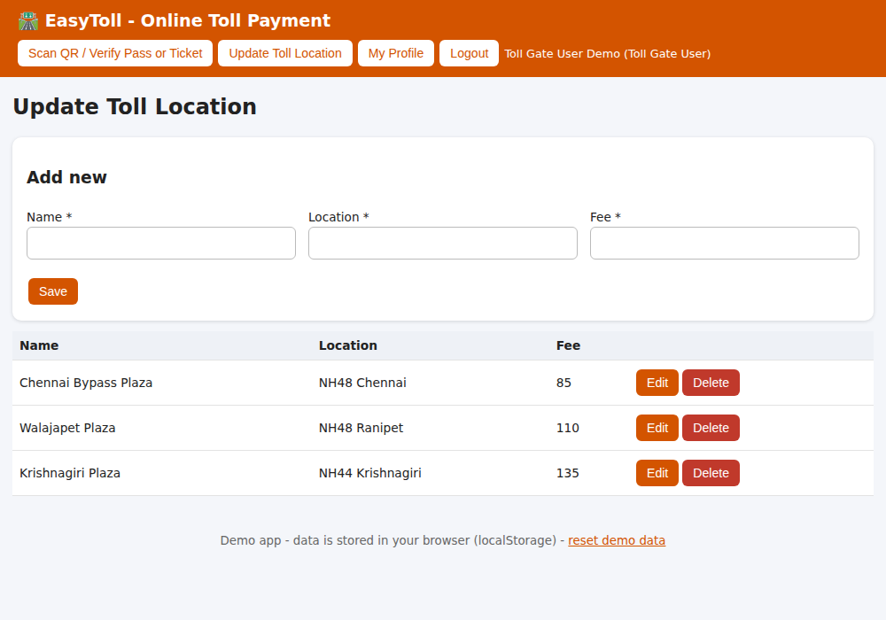
Figure 10: Toll Gate User - Update Toll Location

Result
Thus the EasyToll - Online Toll Payment web application was designed, implemented and executed successfully, and the output was verified for all user roles.

